# How To: Use Pavlovia

When you have completed your PsychoPy Builder experiment and you want to run the study online you need to follow some simple steps.

1. You must create an account using your @hope email address on Pavlovia by using the Register tab on this link <https://gitlab.pavlovia.org/users/sign_in>
2. Once logged in your home page in Pavlovia should look like the image in Figure 1

Figure 1

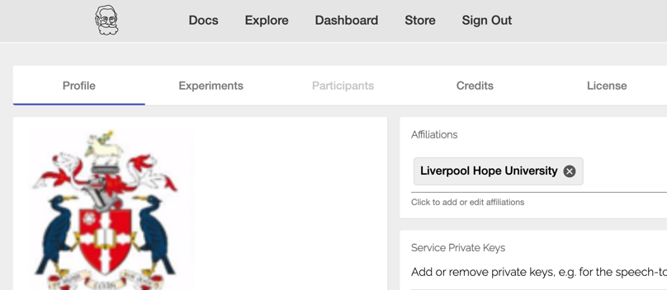

1. Next you should return to your completed experiment in PsychoPy Builder. On the top menu click **Pavlovia.org🡪User🡪Log in to Pavlovia**

Figure 2

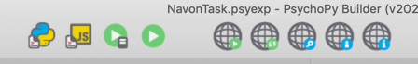

a

b

c

b

1. Click the icons as follows (Figure 2)
   1. Compile to Python
   2. Compile to js
   3. Sync to project on Pavlovia
2. You may get a message saying that your experiment is not associated with any project on Pavlovia, select **Create a project**

Figure 3

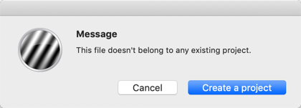

1. You will get a dialog box as per Figure 4

Your Pavlovia username

The path to the location of your folder

Your task name username

Figure 4

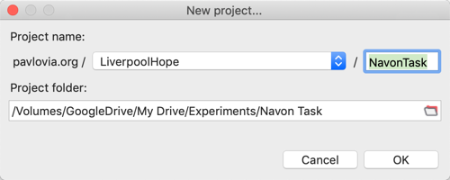

1. Next you will see a dialog box that informs how many files you are **‘pushing’** to Pavlovia. In the details of changes, you should write brief notes to indicate if this is the ‘**first commit’** or you are editing something, e.g. ‘added instructions to instr Routine’

Figure 5

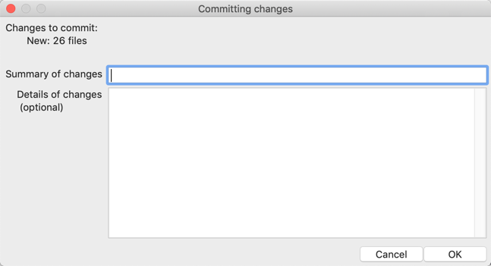

1. You will then get a confirmation that the project has synced

Figure 6

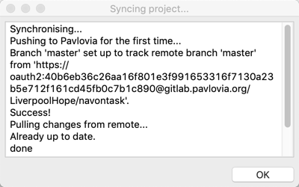

1. If you make any changes, you should simply use the sync button to push any changes to Pavlovia. Do not move your files/folder as this will break the connection to Pavlovia
2. Next you **can return to Pavlovia** and the **Experiments** tab, where you should see your experiment listed. By default it is set to **inactive** and **private**

Figure 7

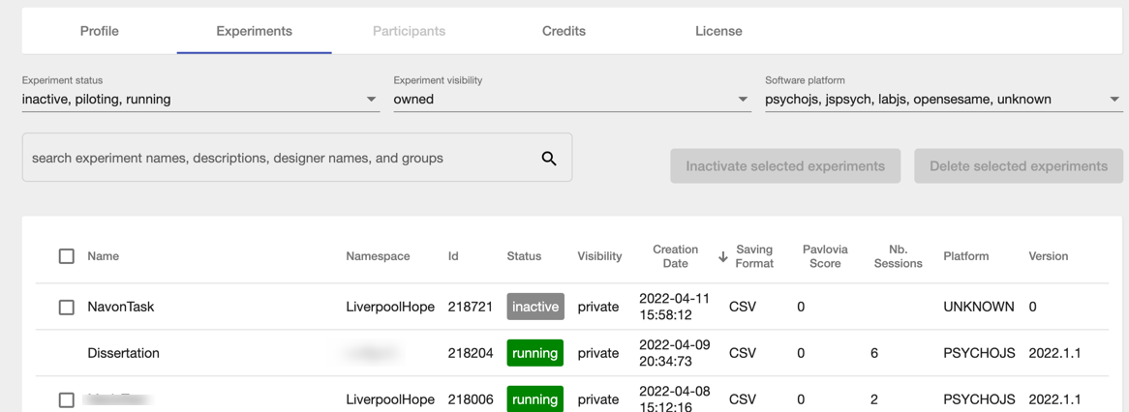

1. Click on your task to take you to the next screen where you can pilot/run your study.
   1. Clicking the **Piloting block** will provide a temporary URL to pilot test the experiment
   2. Clicking on **Running** will provide a permanent URL to distribute to participants

Select Running

Select Piloting

1. Now you need to click on **View Code** and this will take you to your personal GitLab repository (repo) and you. should see something that looks like Figure. 8

Figure 8

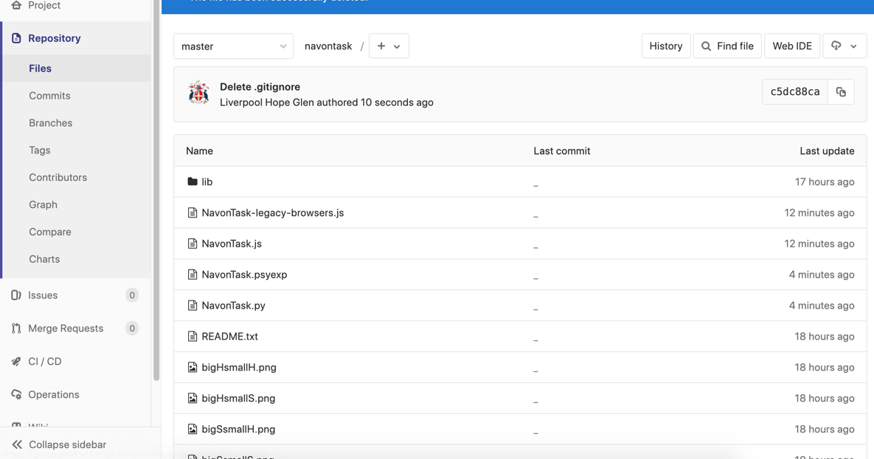

1. When you compiled the script to python and js, this created files that allow you to run your study online. Once you have run the study, a data folder will also appear in the repo containing .csv and log files

Figure 9

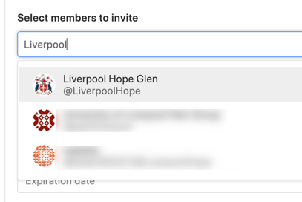

1. From the sidebar, click Settings🡪Member to add collaborators. You must add @LiverpoolHope by searching Liverpool Hope Glen (Figure 9) as a maintainer
2. It is rare that your study will run perfectly on the first attempt, hence why it is crucial that you run a pilot test. See the Common Pavlovia Errors section on the googlesite for more information
3. If you want to download a pre-existing task to use or modify (check permissions) then in Git you can click on the task you want to download which will take you to the page for that task

Figure

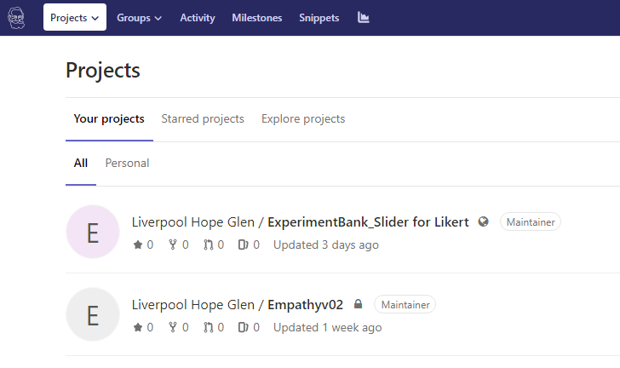

1. There are a couple of ways you can work on the task, you can download using the cloud and arrow button or you can fork it <https://pavlovia.org/docs/experiments/create-fork> then clone it